## Main Idea

I have implemented a Cafe Finder app, where the user initially enters the cafe he/ she is interested in visiting. The app shows other cafes which are close to the cafe user has searched for on a map. For better clarity, the cafe he has searched for is displayed with a red marker, and the near-by cafes are shown with blue markers. The user can also view the near-by cafes as a list, with high-rated cafes shown first. User can easily navigate between the map view and list view of cafes by using a handy navigation drawer. Time to time useful messages are also shown to the user.

## Application and UI design

I have implemented the following features in the Cafe Finder app:

### MapView

for displaying current location, searched cafe, and cafes nearby the searched cafe. Different colored Markers are used for easy viewing of the search results.

### Search UI

for searching the cafe by name

### Customized Material Theme

for styling application UI

### Material Design NavigationView

for implementing navigation drawer

### Snackbar

for showing useful messages.

### RecyclerView, CardView

for displaying a list-like view of near-by cafes, sorted according to their ratings, in an efficient manner.

Apart from these UI elements, following classes are used to implement the functionality

### Google Maps, Places API, Geocoder, FusedLocationClient

for location-related functionality

### Intents

for starting new activity and passing data

### HTTPURLConnection and related classes, JSONObject

for fetching data from web services and parsing it

## App Screenshots

1. Map View

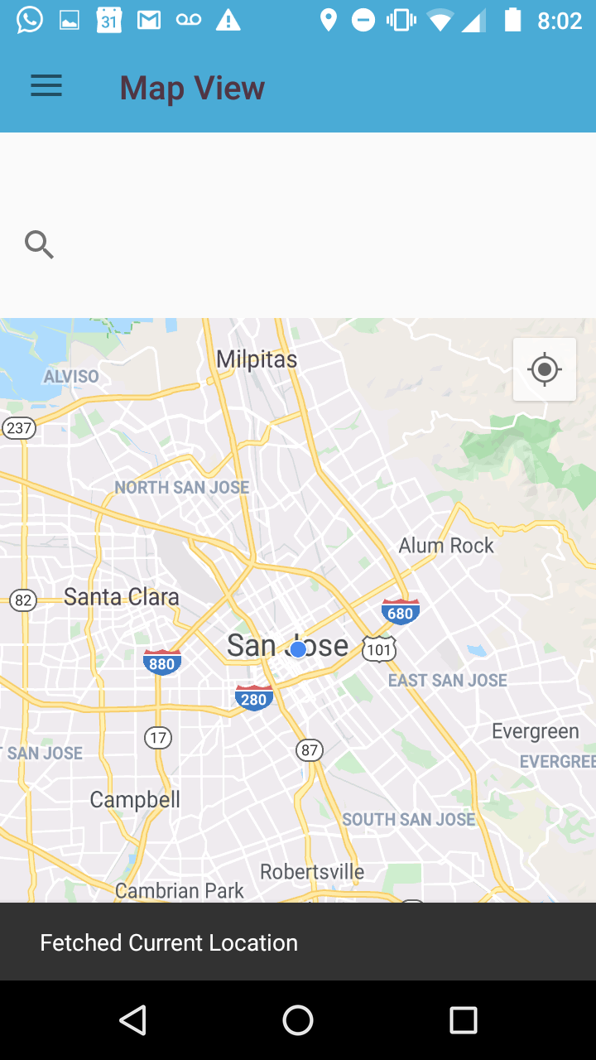

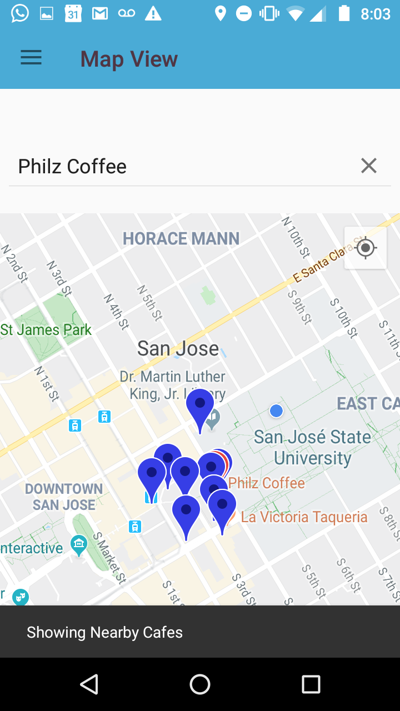

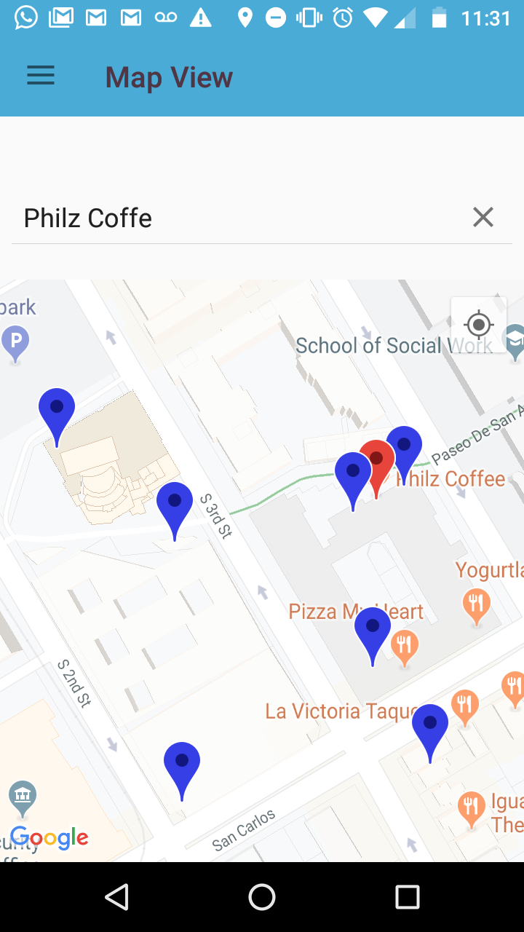

1. Recycler View

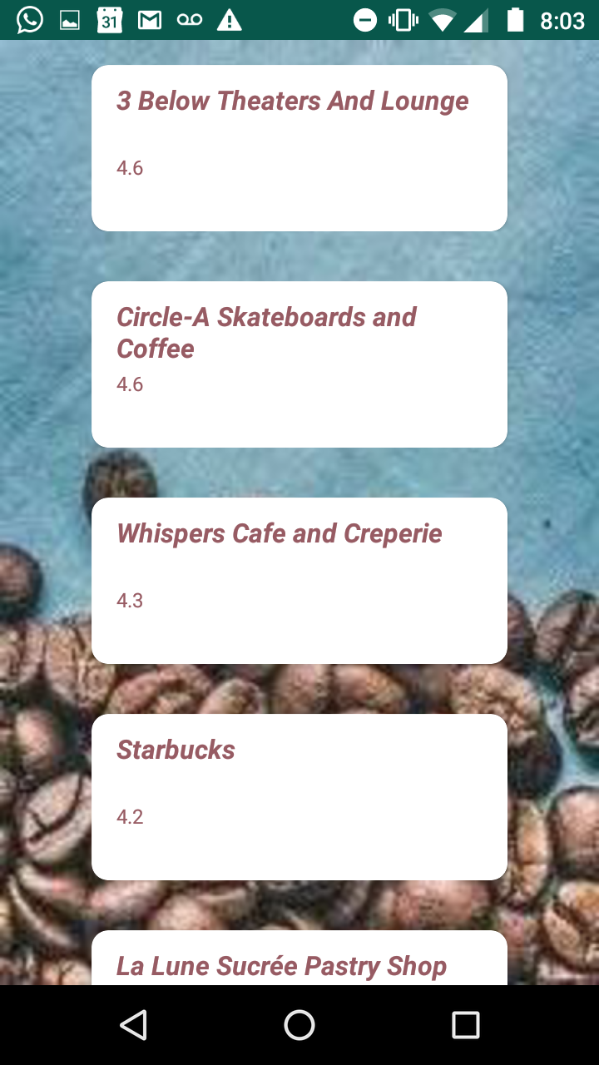

1. Navigation Drawer

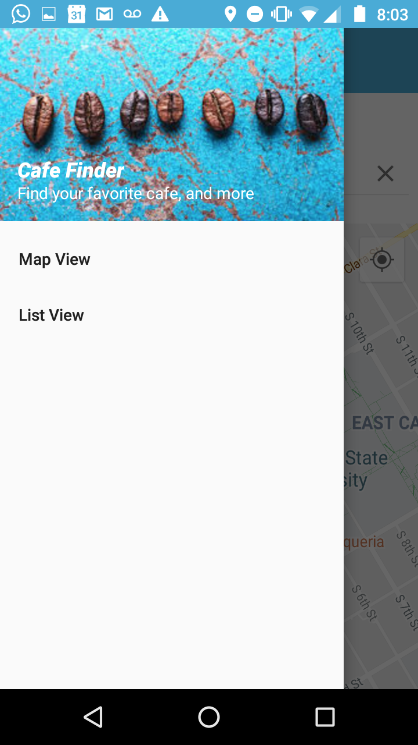

Location-based functionality code

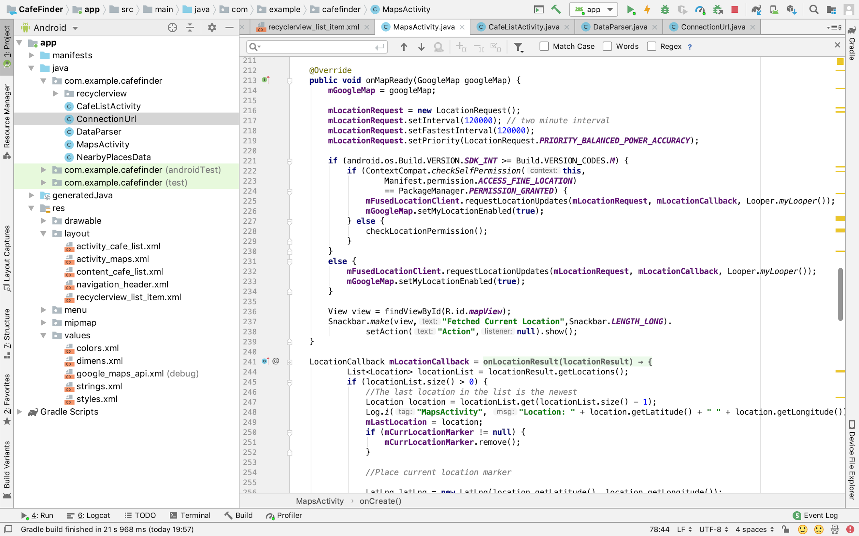

Code for RecyclerView

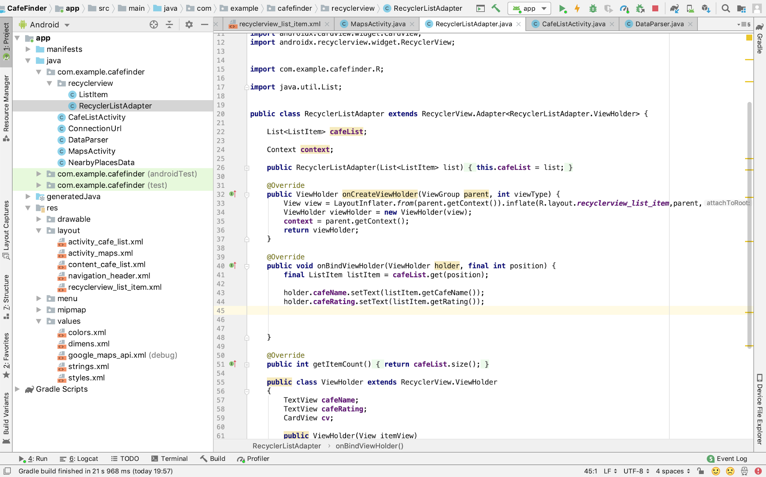

Code for Navigation Drawer

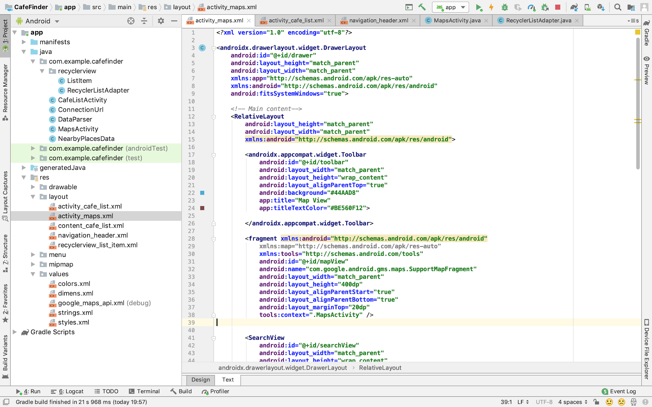

### Profiler Screenshots

